1.
#include <stdio.h>
struct Student {
int id;
char name[50];
int age;
char department[50];
int year;
char address[100];
int mobile;
float science_marks;
float maths_marks;
float english_marks;
};
int main() {
struct Student s;
printf("Enter Student ID: ");
scanf("%d", &s.id);
printf("Enter Name: ");
scanf("%s", &s.name);
printf("Enter Age: ");
scanf("%d", &s.age);
printf("Enter Department: ");
scanf("%s", s.department);
printf("Enter Year of Study: ");
scanf("%d", &s.year);
printf("Enter Address: ");
scanf("%s", s.address);
printf("Enter Mobile Number: ");
scanf("%s", s.mobile);
printf("Enter Marks in Science: ");
scanf("%f", &s.science_marks);
printf("Enter Marks in Maths: ");
scanf("%f", &s.maths_marks);
printf("Enter Marks in English: ");
scanf("%f", &s.english_marks);
printf("\nStudent Details:\n");
printf("ID: %d\n", s.id);
printf("Name: %s\n", s.name);
printf("Age: %d\n", s.age);
printf("Department: %s\n", s.department);
printf("Year of Study: %d\n", s.year);
printf("Address: %s\n", s.address);
printf("Mobile: %s\n", s.mobile);
printf("Marks - Science: %.2f, Maths: %.2f, English: %.2f\n", s.science_marks,
s.maths_marks, s.english_marks);
return 0;
}
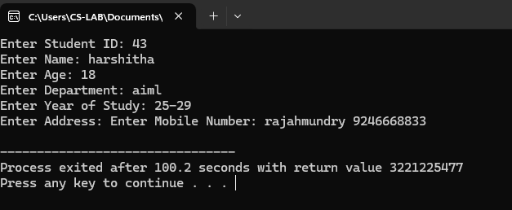
2.
#include <stdio.h>
struct Student {
int id;
char name[50];
int age;
char department[50];
int year;
char address[100];
char mobile[15];
float science_marks;
float maths_marks;
float english_marks;
};
int main() {
struct Student students[10];
int i;
for (i = 0; i < 10; i++) {
printf("Enter details of Student %d\n", i + 1);
printf("Enter Student ID: ");
scanf("%d", &students[i].id);
printf("Enter Name: ");
scanf("%s", students[i].name);
printf("Enter Age: ");
scanf("%d", &students[i].age);
printf("Enter Department: ");
scanf("%s", students[i].department);
printf("Enter Year of Study: ");
scanf("%d", &students[i].year);
printf("Enter Address: ");
scanf("%s", students[i].address);
printf("Enter Mobile Number: ");
scanf("%s", students[i].mobile);
printf("Enter Marks in Science: ");
scanf("%f", &students[i].science_marks);
printf("Enter Marks in Maths: ");
scanf("%f", &students[i].maths_marks);
printf("Enter Marks in English: ");
scanf("%f", &students[i].english_marks);
printf("\n");
}
printf("\nStudent Details:\n");
for (i = 0; i < 10; i++) {
printf("\nDetails of Student %d\n", i + 1);
printf("ID: %d\n", students[i].id);
printf("Name: %s\n", students[i].name);
printf("Age: %d\n", students[i].age);
printf("Department: %s\n", students[i].department);
printf("Year of Study: %d\n", students[i].year);
printf("Address: %s\n", students[i].address);
printf("Mobile: %s\n", students[i].mobile);
printf("Marks - Science: %.2f, Maths: %.2f, English: %.2f\n",
students[i].science_marks, students[i].maths_marks, students[i].english_marks);
}
return 0;
}
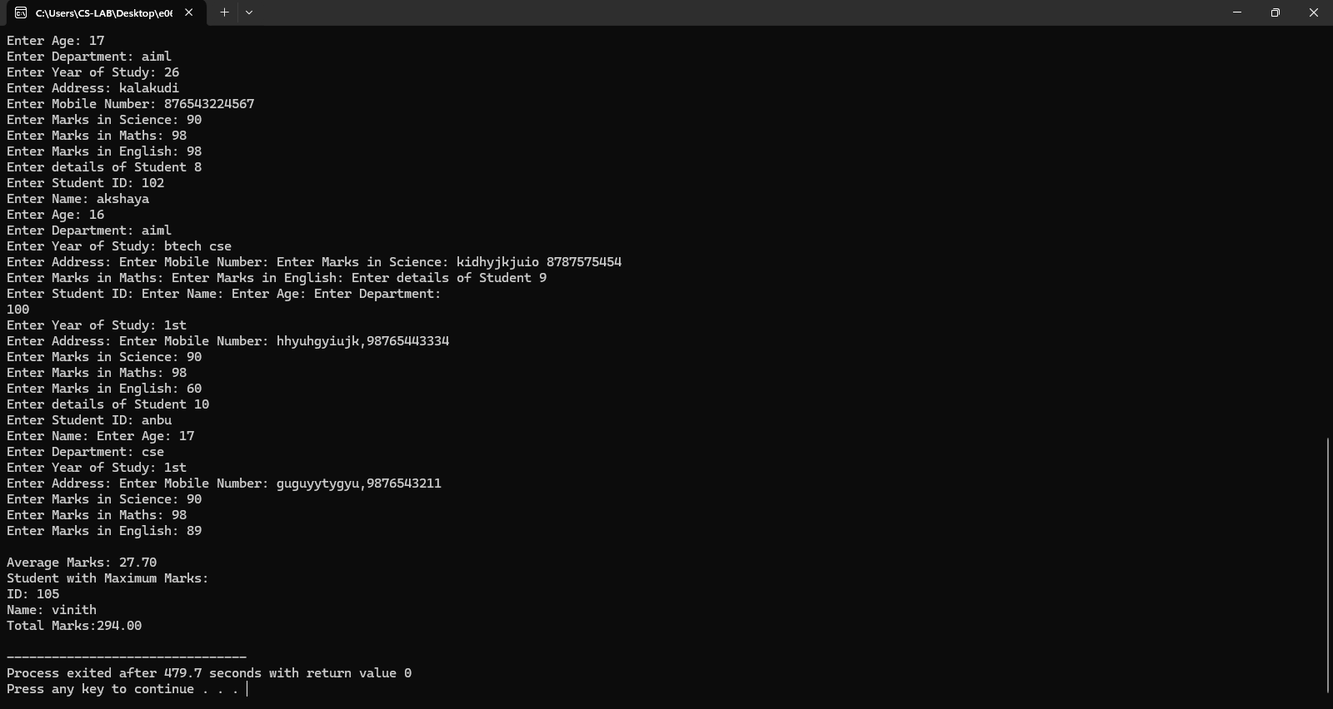
4.
#include <stdio.h>
struct Address {
char street[50];
char city[50];
char state[50];
char zip_code[10];
};
struct Student {
int id;
char name[50];
int age;
char department[50];
int year;
struct Address address;
char mobile[15];
float science_marks;
float maths_marks;
float english_marks;
};
int main() {
struct Student s;
printf("Enter Student ID: ");
scanf("%d", &s.id);
printf("Enter Name: ");
scanf("%s", s.name);
printf("Enter Age: ");
scanf("%d", &s.age);
printf("Enter Department: ");
scanf("%s", s.department);
printf("Enter Year of Study: ");
scanf("%d", &s.year);
printf("Enter Street: ");
scanf("%s", s.address.street);
printf("Enter City: ");
scanf("%s", s.address.city);
printf("Enter State: ");
scanf("%s", s.address.state);
printf("Enter Zip Code: ");
scanf("%s", s.address.zip_code);
printf("Enter Mobile Number: ");
scanf("%s", s.mobile);
printf("Enter Marks in Science: ");
scanf("%f", &s.science_marks);
printf("Enter Marks in Maths: ");
scanf("%f", &s.maths_marks);
printf("Enter Marks in English: ");
scanf("%f", &s.english_marks);
printf("\nStudent Details:\n");
printf("ID: %d\n", s.id);
printf("Name: %s\n", s.name);
printf("Age: %d\n", s.age);
printf("Department: %s\n", s.department);
printf("Year of Study: %d\n", s.year);
printf("Address: %s, %s, %s, %s\n", s.address.street, s.address.city,
s.address.state, s.address.zip_code);
printf("Mobile: %s\n", s.mobile);
printf("Marks - Science: %.2f, Maths: %.2f, English: %.2f\n", s.science_marks,
s.maths_marks, s.english_marks);
return 0;
}
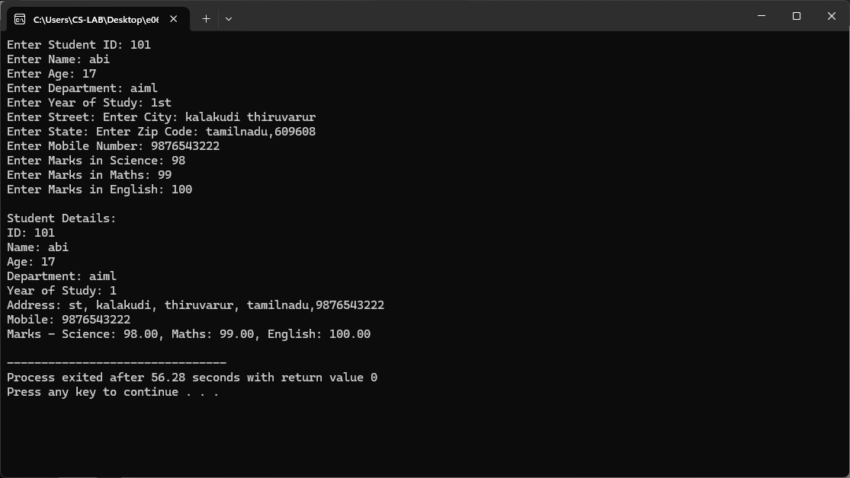
5.
#include <stdio.h>
struct Employee {
int id;
char name[50];
float hours_worked;
float rate_per_hour;
float gross_salary;
};
int main() {
struct Employee emp;
printf("Enter Employee ID: ");
scanf("%d", &emp.id);
printf("Enter Name: ");
scanf("%s", emp.name);
printf("Enter Hours Worked: ");
scanf("%f", &emp.hours_worked);
printf("Enter Rate per Hour: ");
scanf("%f", &emp.rate_per_hour);
emp.gross_salary = emp.hours_worked * emp.rate_per_hour;
printf("\nEmployee Payroll Details:\n");
printf("ID: %d\n", emp.id);
printf("Name: %s\n", emp.name);
printf("Hours Worked: %.2f\n",
emp.hours_worked); printf("Rate per Hour: %.2f\n",
emp.rate_per_hour); printf("Gross Salary: %.2f\n",
emp.gross_salary);
return 0;
}
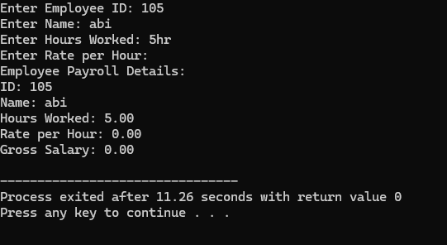
#include <stdio.h>
struct Student {
int rollNo;
float marks;
char grade;
};
int main() {
struct Student s;
printf("Enter roll number: ");
scanf("%d", &s.rollNo);
printf("Enter marks: ");
scanf("%f", &s.marks);
if (s.marks >= 90)
s.grade = 'A';
else if (s.marks >= 75)
s.grade = 'B';
else if (s.marks >= 50)
s.grade = 'C';
else
s.grade = 'D';
printf("\nStudent Details:\n");
printf("Roll Number: %d\n", s.rollNo);
printf("Marks: %.2f\n", s.marks);
printf("Grade: %c\n", s.grade);
return 0;
}
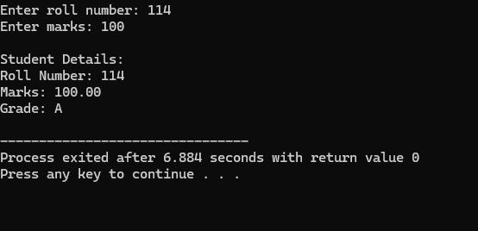
#include <stdio.h>
struct Employee {
int empId;
float salary;
char grade;
};
int main() {
struct Employee e;
printf("Enter Employee ID: ");
scanf("%d", &e.empId);
printf("Enter Salary: ");
scanf("%f", &e.salary);
if (e.salary >= 90000)
e.grade = 'A';
else if (e.salary >= 75000)
e.grade = 'B';
else if (e.salary >= 50000)
e.grade = 'C';
else
e.grade = 'D';
printf("\nEmployee Details:\n");
printf("Employee ID: %d\n", e.empId);
printf("Salary: %.2f\n", e.salary);
printf("Grade: %c\n", e.grade);
return 0;
}
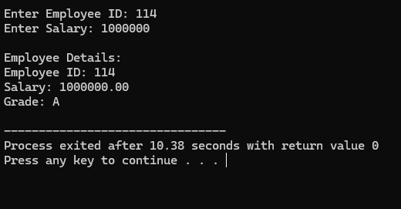
3.
#include<stdio.h>
struct Student {
int id;
char name[50];
int age;
char department[50];
int year;
char address[100];
char mobile[15];
float science_marks;
float maths_marks;
float english_marks;
};
int main() {
struct Student students[10];
int i, max_index = 0;
float total_marks[10], average, max_marks = 0.0;
for (i = 0; i < 10; i++) {
printf("Enter details of Student %d\n", i + 1);
printf("Enter Student ID: ");
scanf("%d", &students[i].id);
printf("Enter Name: ");
scanf("%s", students[i].name);
printf("Enter Age: ");
scanf("%d", &students[i].age);
printf("Enter Department: ");
scanf("%s", students[i].department);
printf("Enter Year of Study: ");
scanf("%d", &students[i].year);
printf("Enter Address: ");
scanf("%s", students[i].address);
printf("Enter Mobile Number: ");
scanf("%s", students[i].mobile);
printf("Enter Marks in Science: ");
scanf("%f", &students[i].science_marks);
printf("Enter Marks in Maths: ");
scanf("%f", &students[i].maths_marks);
printf("Enter Marks in English: ");
scanf("%f", &students[i].english_marks);
total_marks[i] = students[i].science_marks + students[i].maths_marks +
students[i].english_marks;
if (total_marks[i] > max_marks) {
max_marks = total_marks[i];
max_index = i;
}
}
average = 0;
for (i = 0; i < 10; i++) {
average = total_marks[i]/10;
}
printf("\nAverage Marks: %.2f\n", average);
printf("Student with Maximum Marks:\n");
printf("ID: %d\n", students[max_index].id);
printf("Name: %s\n",
students[max_index].name); printf("Total Marks:%.2f\n", max_marks);
return 0;
}
